SERIES 3000MR/3000MRS | PHOTOHELIC® SWITCH/GAGE

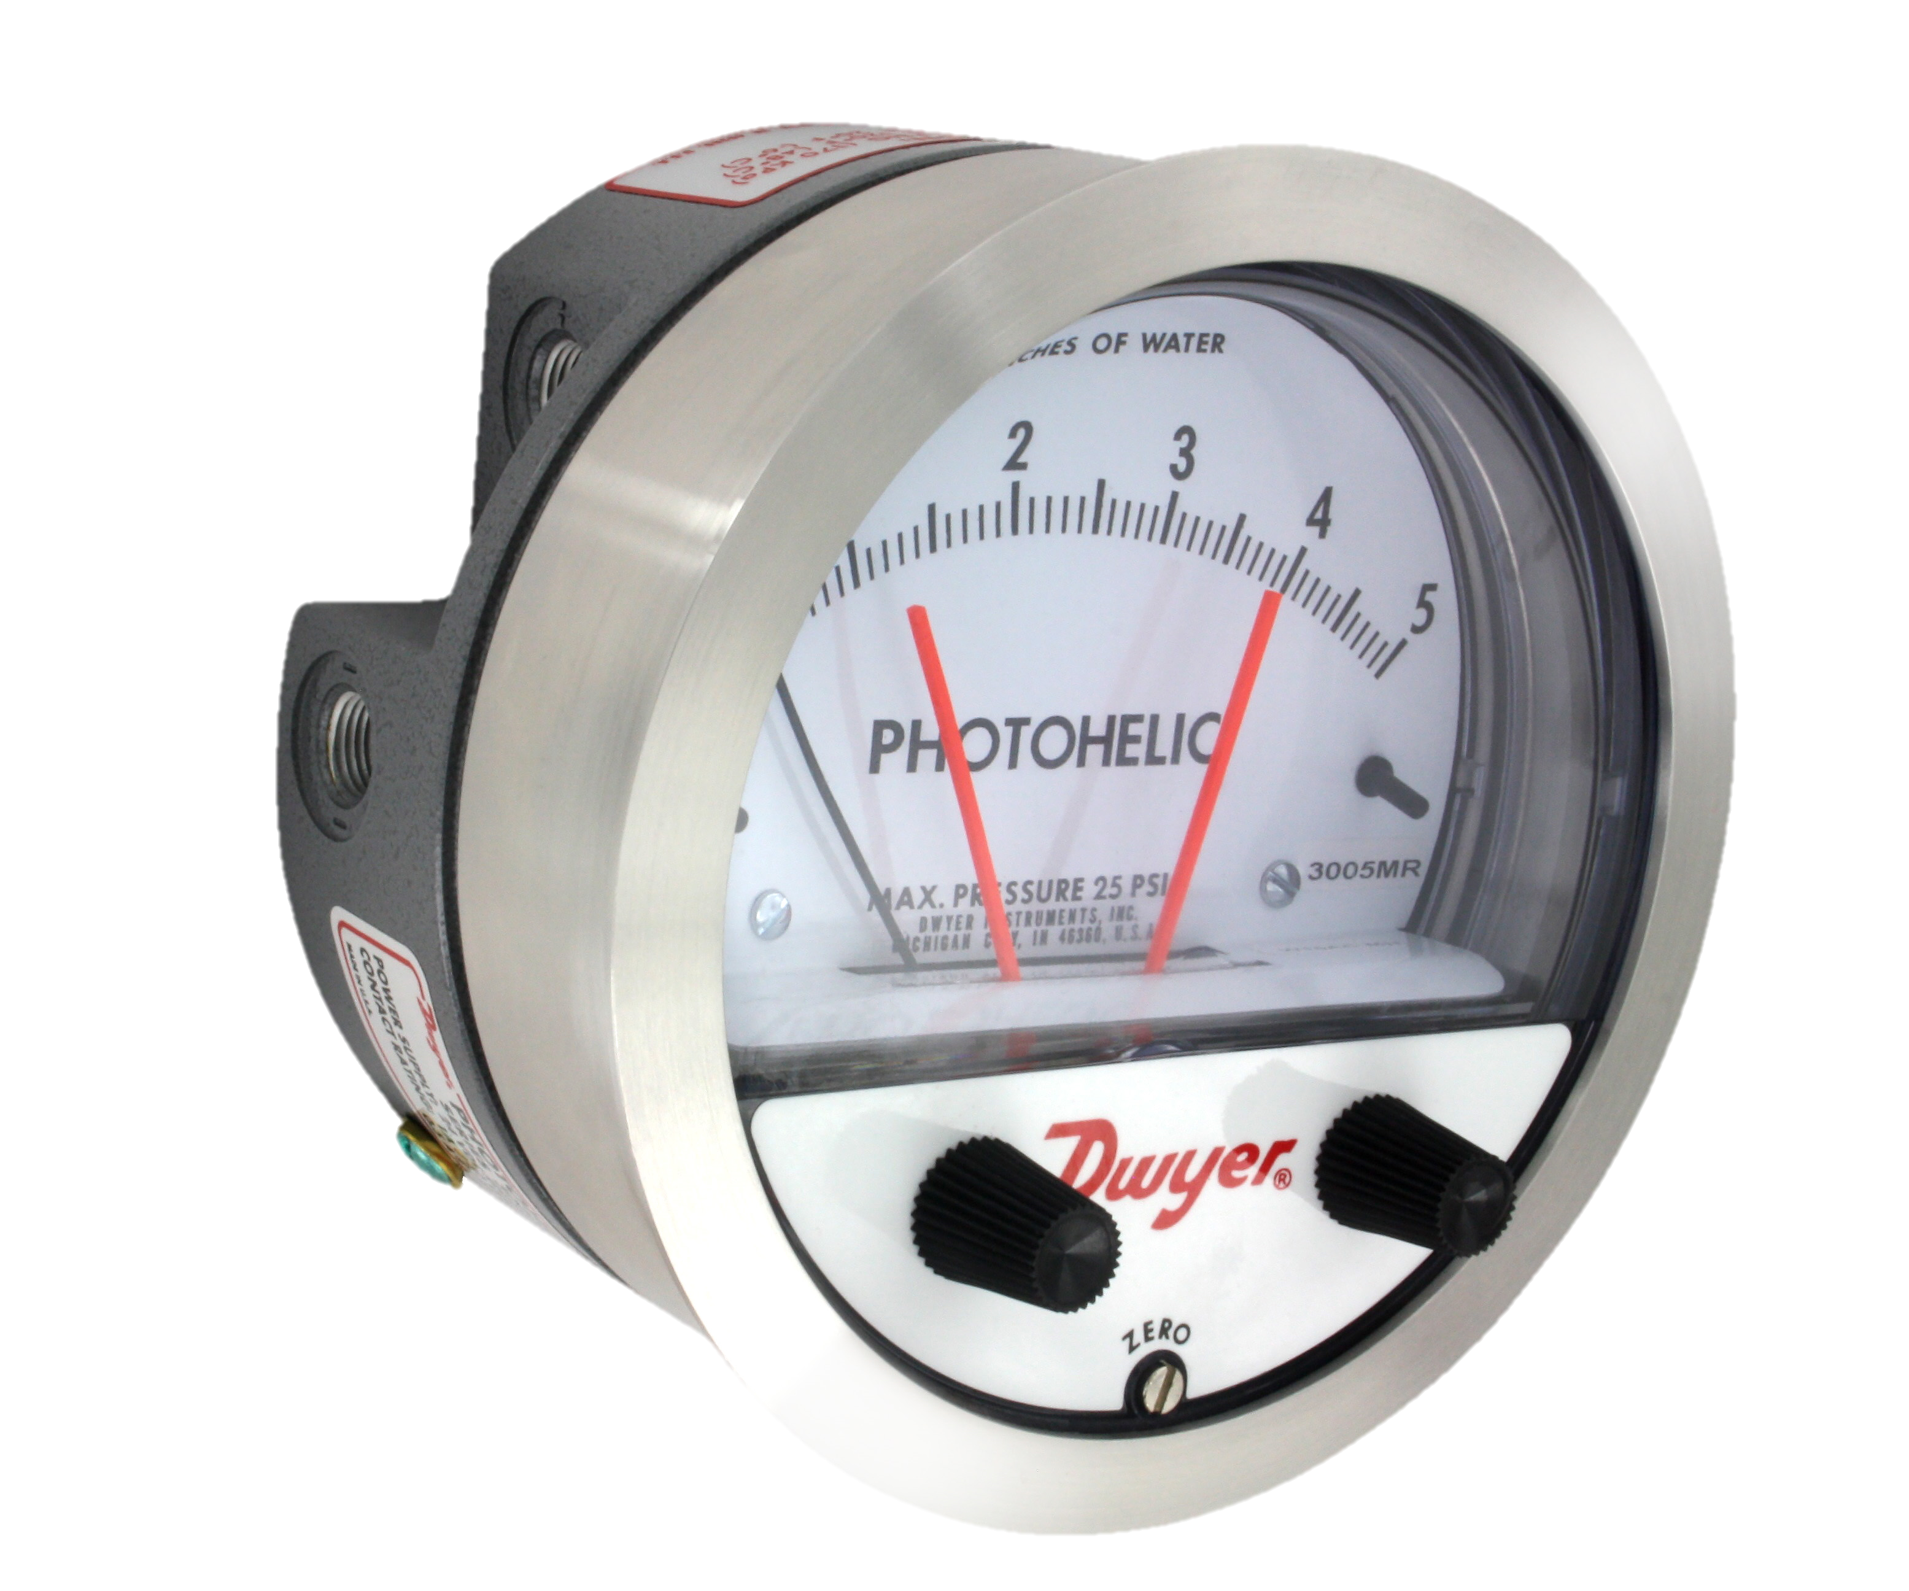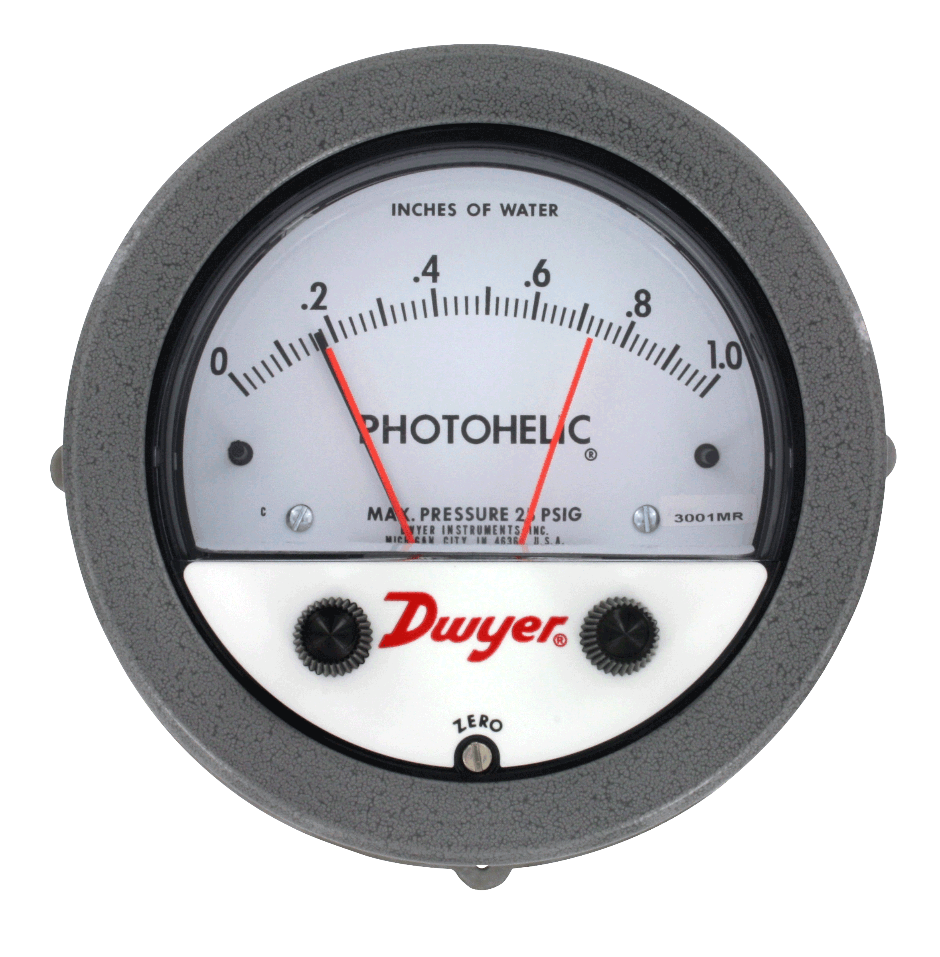FEATURES/BENEFITS
- Gage reading unaffected by switch operation and will continue to read pressure even during power loss
- Zero and range adjustments outside of gage means no disassembly in normal service
- Solid state design allows for switching in high cycle rate applications without degradation
- Optional stainless steel bezel is the same installation diameter as Magnehelic® gage and simplifies field upgrade to Photohelic® switch/gage

APPLICATIONS
- Pneumatic conveying
- Air conditioning systems
- Clean rooms

DESCRIPTION
Using solid state technology, the SERIES 3000MR & 3000 MRS Photohelic® Switches/Gages combine the functions of a precise, highly repeatable differential pressure switch with a large easy-to-read analog pressure gage employing the durable, time-proven Magnehelic® gage design. Switch setting is easy to adjust with large external knobs on the gage face. Gage reading is unaffected by the switch operation will indicate accurately even if power is interrupted. Solid state design now results in greatly reduced size and weight. Units can be flush mounted or surface mounted with hardware supplied. 3000MR models employ versatile electromechanical relays with gold over silver contacts – ideal for dry circuits. For applications requiring high cycle rates, choose 3000MRS models with SPST (N.O.) solid state relays. All models provide both low and high limit control and include 18-inch (45 cm) cable assemblies for electrical connections. Compatible with air and other non-combustible, non-corrosive gases, they can be used in systems with pressures to 25 psig (1.725 bar). Optional construction is available for use to either 35 psig (2.42 bar) or 80 psig (5.51 bar).

Note: Shown with optional -SS bezel.
Backward compatible with Magnehelic® gage.

DWYER INSTRUMENTS, INC.

GAGE SPECIFICATIONS
Service | Air and non-combustible, compatible gases.
Wetted Materials | Consult factory.
Accuracy | ±2% of FS (3000-0 ±3% of FS). (3000-00 ±4% of FS).
Pressure Limit | -20" Hg to 35 psig (-0.677 bar to 1.72 bar). MP option: 35 psig (2.41 bar), HP option: 80 psig (5.52 bar).
Temperature Limits | 20 to 120°F (-6.67 to 48.9°C).
Process Connections | 1/8" female NPT (duplicated side and back).
Size | 4" (101.6 mm) dial face, 5" (127 mm) OD x 3-1/8" (79.38 mm); -SS Bezel: 4-3/4" (120.7 mm) OD x 2-21/32" (67.5 mm).
Weight | 1.8 lb (816 g).

3000 MR SWITCH SPECIFICATIONS
Switch Type | Each set point has 1 form C relays (SPDT)
Relay Contacts | (Resistive load) 1 form C rated 1.0 A @ 30 VDC, 0.3 A @ 110 VDC or 0.5 A @ 125 VAC. Gold over clad silver – suitable for dry circuits.
Electrical Connections | 18" (46 cm) cable assembly with 8 conductors. Optional lengths to 100' (30.5 m).
Power Requirements | 24 VDC, regulated 10%.
Mounting Orientation | Diaphragm in vertical position. Consult factory for other position orientations.
Set Point Adjustment | Adjustable knobs on face.
Agency Approvals | CE.

3000MRS SPECIFICATIONS
Switch Type | Each set point has a solid state relay.
Switching Voltage | 20 to 280 VAC (47 to 63 Hz).
Switching Current | 1.0 A (AC) max., 0.01 mA (AC) min., (2) SPST NO.
Electrical Connections | 18" (46 cm) cable assembly with 6 conductors, optional lengths to 100' (30.5 m).
Power Requirements | 24 VDC, regulated ±10%.
Mounting Orientation | Diaphragm in vertical position. Consult factory for other position orientations.
Set Point Adjustment | Adjustable knobs on face.
Agency Approvals | CE.

DWYER INSTRUMENTS, INC.

DIMENSIONS

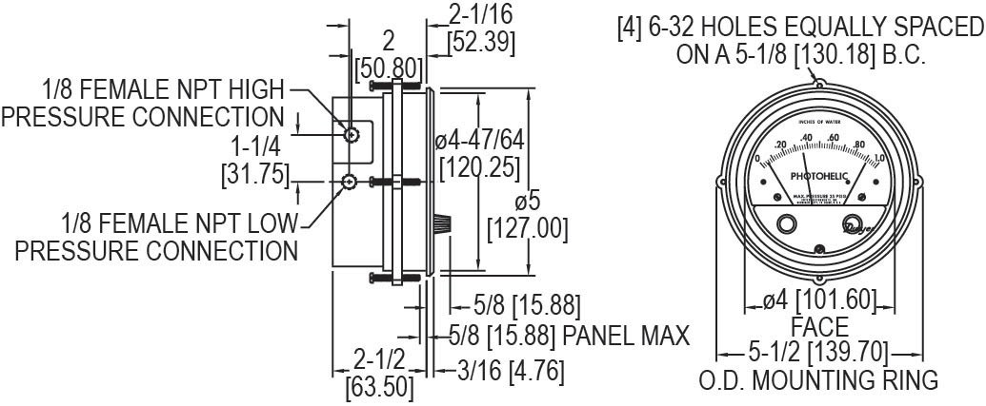

WIRING DIAGRAM

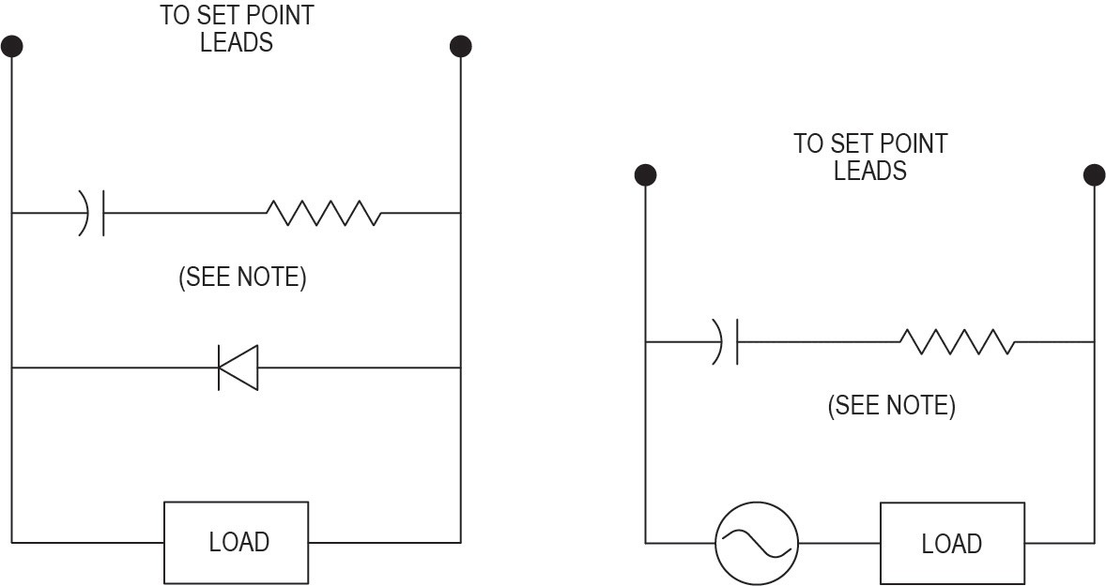
3000MR 3000MRS

DWYER INSTRUMENTS, INC.

HOW TO ORDER
Use the bold characters from the chart below to construct a product code
3001 MR -SS

SERIES/RANGE
3001 - 0 to 1 in w.c.
3002 - 0 to 2 in w.c.
3003 - 0 to 3 in w.c.
3004 - 0 to 4 in w.c.
3005 - 0 to 5 in w.c.
3201 - 0 to 1 psid
3202 - 0 to 2 psid
3203 - 0 to 3 psid
3204 - 0 to 4 psid
3205 - 0 to 5 psid
3000XX-125PA - 0 to 125 Pa
3000XX-250PA - 0 to 250 Pa
3000XX-500PA - 0 to 500 Pa
3000XX-60PA - 0 to 60 Pa
OPTIONS
AT - Aluminum tag
BUNA - Buna-N elastomers COO - Certificate of origin EXPL - Explosion-proof housing with breather and drain
HP - High pressure
M - Mirror scale overlay
SS - 304 brushed stainless steel
WP - Weatherproof housing

RELAY TYPE
MR - Electromechanical relays
MRS - Solid state relays

ACCESSORIES

Model | Description
A-298 | Flat aluminum bracket for flush mounting Photohelic® and Capsuhelic® gages, 603A, 605, and 3000MR
A-320-B | Enclosure for 3000MR/MRS Photohelic® Switch/Gage, 605 Magnehelic® DP Transmitter, DH3 Digihelic® Pressure Controller, 2000 Magnehelic®
 | Gage with medium and high pressure options, 4-13/16" (122.24 mm)
A-370 | Flush mount bracket used with: Photohelic® 3000MR/MRS, Capsuhelic®, 631B Transmitter, EDA. Bracket is then surface mounted. Steel with gray
 | hammertone epoxy finish
A-600 | R/C snubber (recommended for inductive loads like a solenoid or contactor)

Important Notice: Dwyer Instruments, Inc. reserves the right to make changes to or discontinue any product or service identified in this publication without notice. Dwyer advises its customers to obtain the latest version of the relevant information to verify, before placing any orders, that the information being relied upon is current.

dwyer-inst.com
DWYER INSTRUMENTS, INC.

DS-3000MR/3000MRS | 7/17

